# Exercise: Decoding Marks and Channels

Exercise Provided by: [Enrico Bertini](http://enrico.bertini.io/teaching/), NYU Tandon

**Learning Goal:** Train yourself in *decoding* charts so that you can better understand how virtually every single visualization can be described using the language and rules of *visual encoding* and decomposed into low-level graphical components.

**How do you know if you are on the right track?** You can describe a chart in terms of its graphical components.

## Instructions

Summary: For each of the 5 charts following, you will identify data **items** and the **marks** used to encode them, and data **attributes** and the **channels** used to encode them. For each chart, you’ll fill in

* Visual channels used?
  + Channel X encodes attrib Y
  + Channel X encodes attrib Y
  + ....
* Marks used?
  + Mark of type X encodes item Y
  + Mark of type X encodes item Y
  + ....

Note that underneath each chart there is a link to a web page providing details about the project, including information about the data and in many cases supporting interactivity. For now just encode what you see in the static image in this document, just notice that interactivity is being used a lot for emphasis (hover highlight, animated transitions, reordering, details popups, small multiples zooming).

Think about how you would reconstruct the dataset underlying this picture. Assume one mark per item, think of items as rows of a table. Assume each channel is showing an attribute, where channel is a column in a (simple) data table. Remember that multiple channels could redundantly encode the same attribute. Notice that a mark is not every single bit of ink on the page- for example, labels and annotations are not marks in the sense that we’re doing this analysis!

**Chart 1**

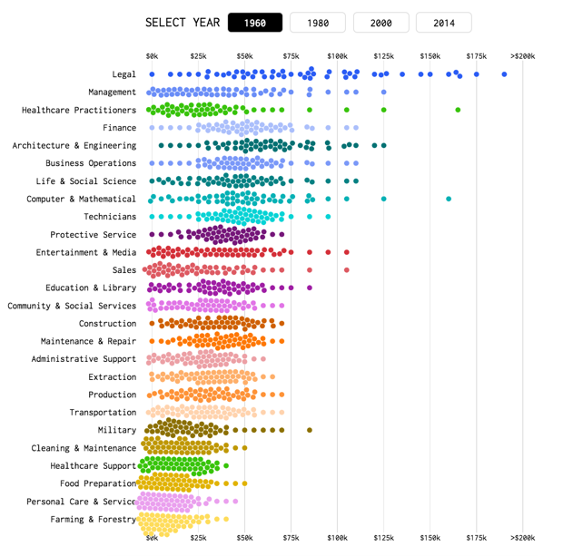

<https://flowingdata.com/2016/06/28/distributions-of-annual-income/>

**Chart 2**

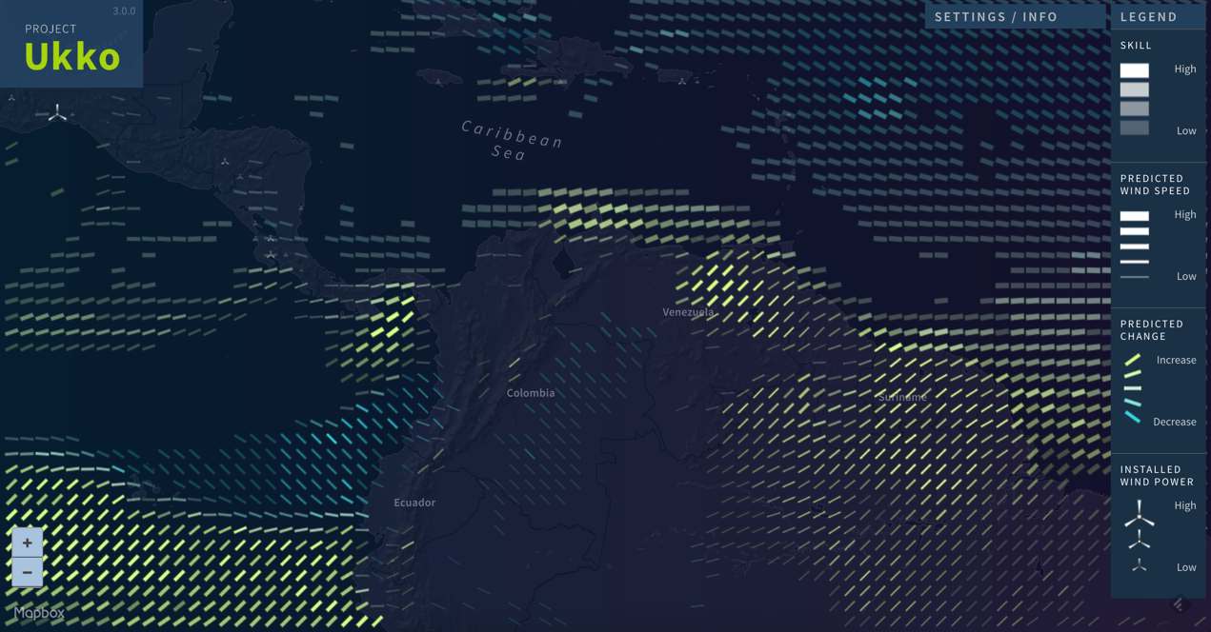

<http://project-ukko.net/>

**Chart 3**

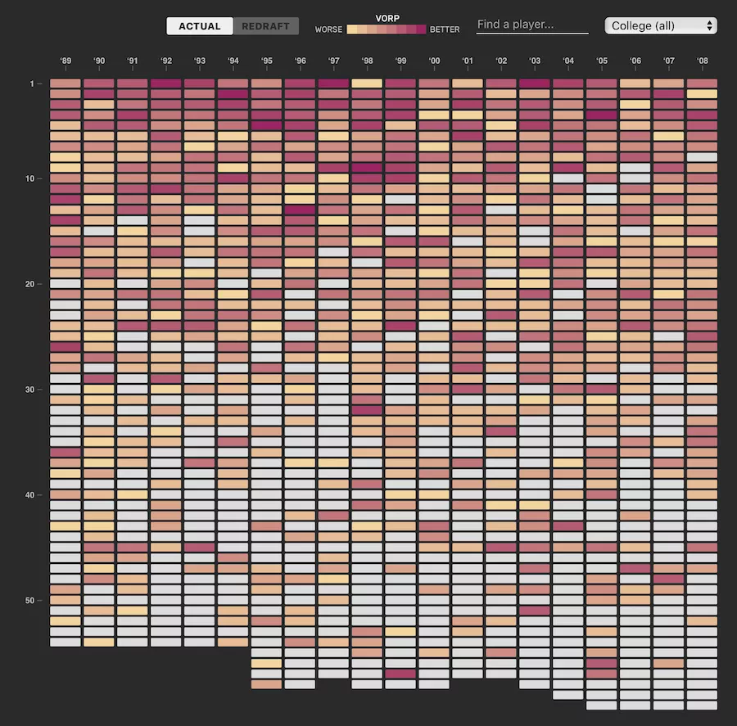

<http://polygraph.cool/redraft/>

**Chart 4**

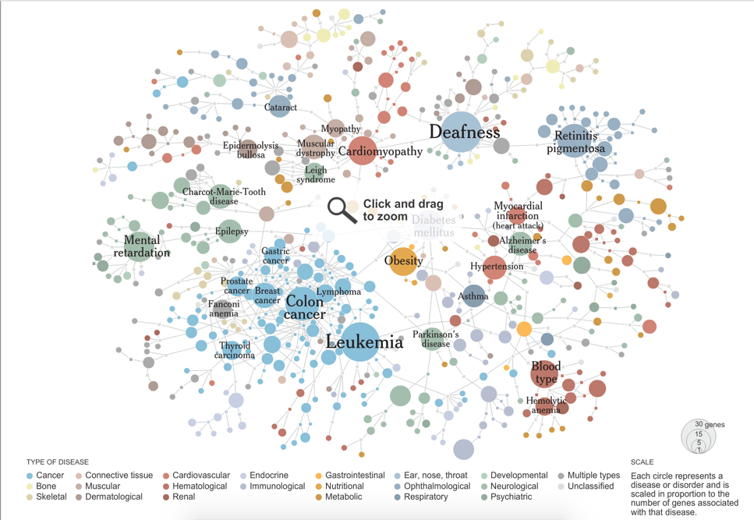<http://www.nytimes.com/interactive/2008/05/05/science/20080506_DISEASE.html>

**Chart 5**

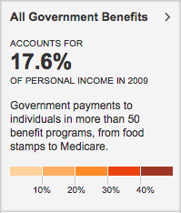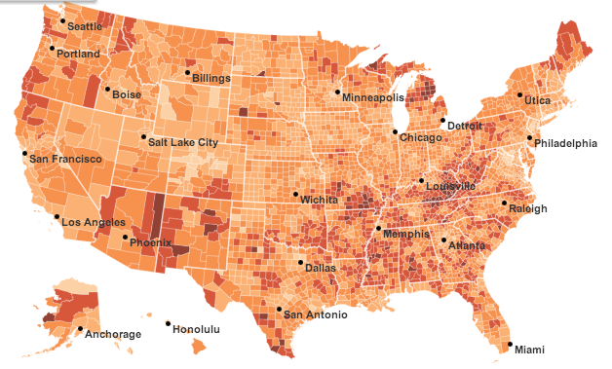

<http://www.nytimes.com/interactive/2012/02/12/us/entitlement-map.html>